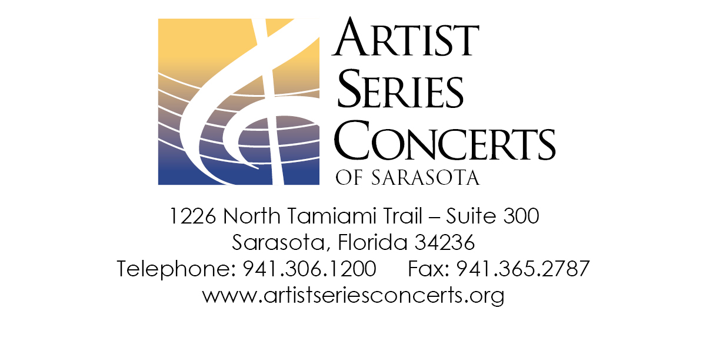

**Shipping Information**

Steve Briggs (customer information here)

VIP World Travel

4971 Ringwood Meadow

Sarasota, FL 34239

Dear Steve Briggs,

Thank you for purchasing tickets from Artist Series Concerts of Sarasota, Inc. The details of your order are listed below. For questions regarding this order, please call Donna Fisk at 941-306-1202, Monday through Friday, 10 – 4 or email [donna@artistseriesconcerts.org](mailto:donna@artistseriesconcerts.org).

(The normal order information and detail can go here)